**Sheet No. – 02**

**Assignment No: 4**

**Queries and their solutions:**

1. **Retrieve the name of the students whose name starts with ‘S’ and contains ‘r’ as the second last character.**

**Query:**

select name

from students

where name like 'S%r_';

**Result:**

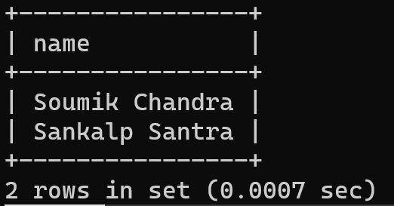

1. **Retrieve the name of the youngest student(s) from the ‘CST’ department along with the total marks obtained by him (them).**

**Query:**

select name, sum(marks)

from students, crs_regd

where deptcode = 'CSE'

and crs_rollno = rollno

and bdate = ( select max(bdate)

from students

where deptcode = 'CSE')

group by name;

**Result:**

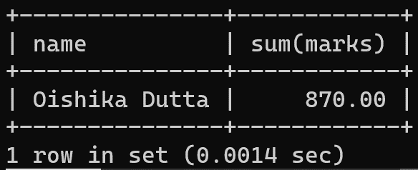

1. **Find the age of all the students.**

**Query:**

select rollno, name, TIMESTAMPDIFF(YEAR, bdate, CURDATE()) as age

from students;

**Result:**

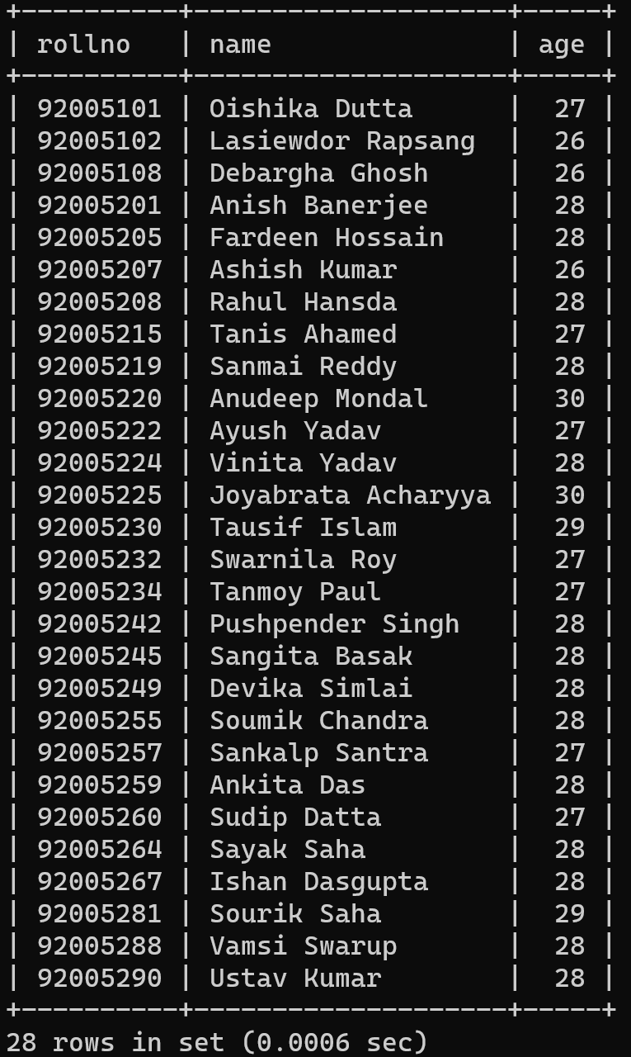

**Assignment No: 5**

**Queries and their solutions:**

1. **Retrieve the name of the student(s) who obtained second highest marks in ‘DBMS’.**

**Query:**

select rollno, name, marks, crs_cd

from students, crs_regd, crs_offrd

where

crs_rollno = rollno

and crs_cd = crs_code

and crs_name = 'DBMS'

and marks = ( select distinct(marks)

from crs_regd, crs_offrd

where crs_cd = crs_code

and crs_name = 'DBMS'

order by marks desc limit 1 offset 1);

**Result:**

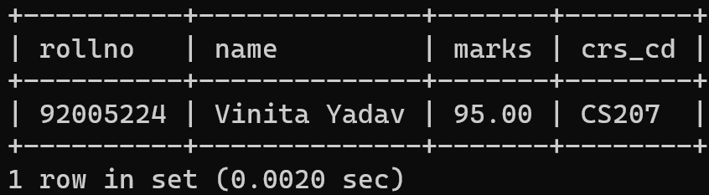

1. **Find out the differences between highest and lowest marks obtained in each subject.**

**Query:**

select crs_cd,max(marks) - min(marks) as mark_diff

from crs_regd

group by crs_cd

order by crs_cd;

**Result:**

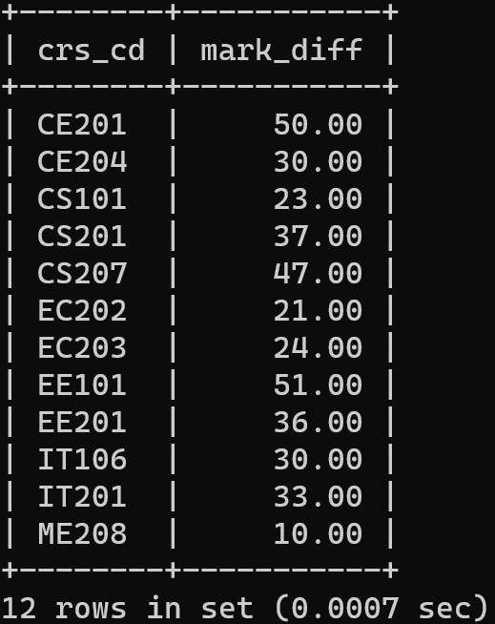

1. **Assuming the existance of several interdepartmental courses, retrieve the name of the student(s) who is(are) studying under at least one faculty from each department.**

**Query:**

select rollno, name

from

crs_offrd

,faculty

,crs_regd

,students

where

crs_fac_cd=fac_code

and crs_cd=crs_code

and crs_rollno=rollno

group by name

having count(distinct(fac_dept)) = (select count(*) from depts);

**Result:**

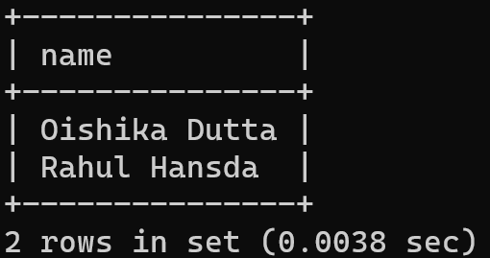

1. **Assuming the existance of several interdepartmental courses, retrieve the name of the student(s) who is(are) studying under the faculties only from his(their) own department.**

**Query:**

select rollno, name

from students

where rollno not in (select distinct(rollno)

from crs_offrd, faculty, crs_regd, students

where crs_fac_cd=fac_code

and crs_cd=crs_code

and crs_rollno=rollno

and fac_dept!=deptcode

group by rollno

union

((select rollno from students) except (select distinct crs_rollno from crs_regd)));

**Result:**

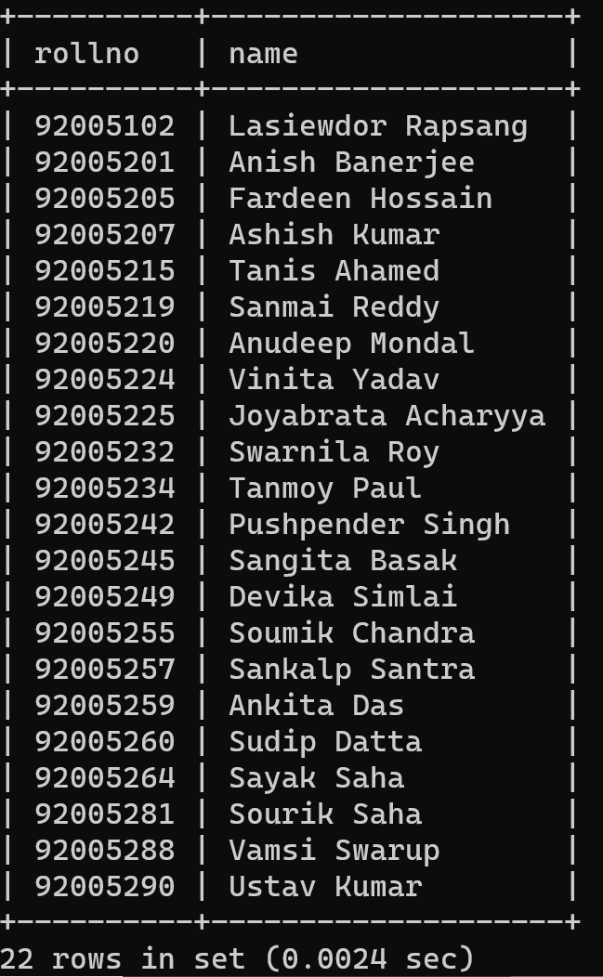

**Assignment No: 6**

1. **Display the highest parent incomes, in descending order, for each department excluding ‘CSE’ such that only those highest parent incomes will appear that are below 2,20,000.**

**Query:**

select name, perent_inc

from students

where

deptcode != 'CSE'

AND perent_inc < 220000

order by perent_inc desc;

**Result:**

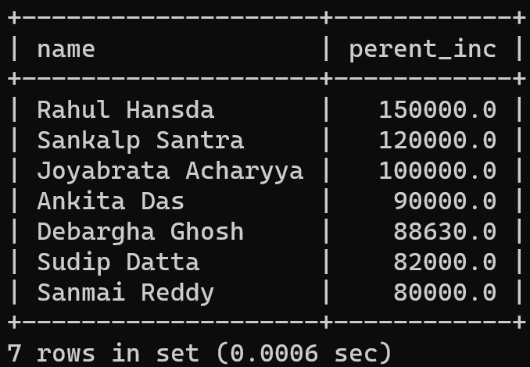

1. **Retrieve the fifth highest parent income for hostel number 5.**

**Query:**

select name, perent_inc

from students

where hostel = 5

order by perent_inc desc limit 1 offset 4;

**Result:**

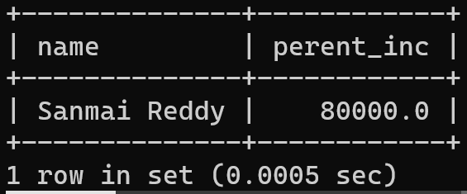

1. **Find the roll number of the students from each department who obtained highest total marks in their own department.**

**Query:**

select name,deptcode,s.rollno

from students as s

where s.rollno = (

select cr.crs_rollno

from crs_regd as cr

where s.deptcode = (

select deptcode

from students

where rollno = cr.crs_rollno

)

group by cr.crs_rollno

order by sum(cr.marks) desc

limit 1

);

**Result:**

